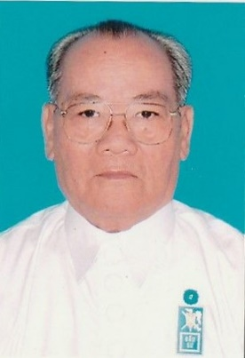

ADDRESS OF CARDINAL THUONG TAM THANH-
CHAIRMAN, CAO DAI SACERDOTAL COUNCIL
TAY NINH HOLY SEE,
AT THE 3rd IRUHA INTERNATIONAL CONFERENCE
IN TAIPEI – TAIWAN – JULY 18th, 2019

Dear Rev. Eiichi Suzuki, President Jinrui-Aizenkai
Dear Religious Leaders and Representatives of different World Culture Organizations
Distinguished guests,
Ladies and Gentlemen,

I, Cardinal Thuong Tam Thanh (Secular name: Nguyen Thanh Tam), Chairman of the Caodai Sacerdotal Council in Tay Ninh Holy See, Viet Nam, and dignitaries members of the Cao Dai delegation, are very honored to be invited by Rev. Eiichi Suzuki, President Jinrui Aizenkai, Oomoto Japan, to this Third IRUHA International Conference, held in Taipei, Taiwan.

First of all, we would like to extend our cordial greetings to Her Highness Kurenai Deguchi, Oomoto Religious Leader, and wish her good health, longevity and happiness.

Second, we want to send to the Leaders of Religions, to all Representatives of the World cultures present today, our sincere and warmest greetings.

Ladies and Gentlemen,

As we all know, Oomoto Jinrui Aizenkai was founded in 1925 by Oomoto Co-Founder Onisaburo Deguchi with the purpose of bringing love to societies in order to realize eternal peace to the world.

With this great goal, Jinrui Aizenkai has organized many conferences in many countries around the world, and through many various activities, tried to spread universal love, with the same idea as our Cao Dai philosophy that ​​all religions in this world have the same origin which is God, that they need to cooperate in order to create peace for Humanity to enjoy and to prospere.

Today, this IRUHA International Conference 2019, opened in Taipei with the presence of many religious and cultural representatives, is considered as a practical journey to world peace, and flourished by creating a synergy, excitement and cooperation between many Religions and many different cultures.

In this joyful atmosphere, I would like to share the teaching of our religion, Cao Dai, that all races in this world believe that we have a common Father who is the Creator, and all religions of the world, despite their different names, have a unique origin, God the Father, which also has different names due to the regional customary languages. Everyone should live peacefully in the great brotherhood, must visit one another, exchange culture, educate and support each other, thus, friendship, love, solidarity and peace will come to this realm.

Today is a day which also reminds me of the Great Day of the Grand Opening of the Unveiling Ceremony of The Golden Mega-Statue of Guiguzi Wang Chan Laozu held in Weixin Shengjiao Bagua City - Taichung in the middle of June of last year 2018, especially with the signing of the Memorandum of Understanding creating The Association of East Asian New Religions between Weixin Shengjiao, Daeson Jinrihoe and Cao Dai, the purpose of which was to link all Religions in order to spread universal love to humanity and to promote world peace.

We wish you all present today happiness and progress in whatever you do. We sincerely wish this Third IRUHA International Conference of Oomoto great success.

Thank you

Taipei July 18, 2019
Cardinal THUONG TAM THANH
(Nguyen Thanh Tam)

