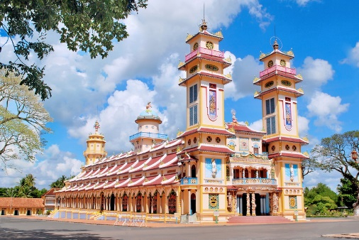

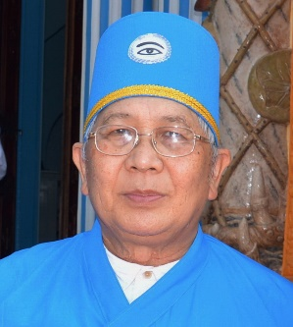
WELCOME ADDRESS

BY REVEREND CANH TRAN, PRESIDENT
CAO DAI OVERSEAS MISSIONARY
AT THE YEOJU ECO-FORUM
Yeoju, Korea, October 3-5, 2019

----------

-His Excellency Yun Eun-Do, President of Daesoon Jinrihoe Yeoju Headquarters
-Dr. John Cobbs, Co-Director of the Center for Process Studies
-Mr. Jay Cha, Organizational Committee General Manager
-Distinguished Religious Leaders and Guests.

Ladies and Gentlemen,

I, Reverend Canh Tran, President, Cao Dai Overseas Missionary, on behalf of Cardinal Thuong Tam Thanh, Chairman of the Cao Dai Sacerdotal Council, Tay Ninh Holy See, Viet Nam, along with members of the Cao Dai TV team and the Cao Dai Youth Orchestra, are very honored and privileged to be invited by the Organizational Committee to attend this first Yeoju Eco-Forum. On behalf of the Sacerdotal Council of Cao Dai Tay Ninh Holy See and of Cao Dai Overseas Missionary, we would like to extend to all of you present today our warmest greetings and best wishes.
We in Cao Dai completely agree with the goal of the Yeoju Eco-Forum which is “to bring together leaders from different religious faiths and top scholars to facilitate a dialogue on ecological civilization, gather constructive wisdom to deal with urgent ecological crises, and take tangible steps towards the creation of a new form of civilization: ecological civilization”. We are completely certain that this Forum would achieve this great goal.
The Cao Dai doctrine and philosophy embrace the love of all living beings, which cover plants, animals and human beings. As you already knew, the destruction of ecological environmental matters has the source of not loving all living beings. Bodhisattva Kwan Yin’s message in 1933 to Cao Dai disciples : “Because all things are born of compassion and kindness in this world, all things are the same. The law of love from God the Creator is boundless, infinite to all living beings. We are a species in all things, then we are also in the law of God. Therefore, if one kills a life, it will hurt the Great Creator, and if anyone who hurts the Great Creator will receive an enormous depression and melancholy. We have to open our heart to charity, to love everyone down to the weak, and to avoid falling into the law of karmic retribution, because Heaven’s law doesn't discriminate anyone”
Talking about ecological problems is a big issue for the whole word, so we would like to concentrate on this theme “How to work together towards the creation of an ecological civilization”. Working together is something that we can accomplish easily between organizations, between religions. The Association of East Asia New Religions which comprised of Daesoon Jinrihoe, Weixin Shengjiao and Cao Dai worked together for the past year in many areas to bring friendship, peace, with social, cultural and educational activities. We sincerely hope that the small accomplishments of this Association would spread to other religions to follow, and little by little we could declare World Peace because everybody recognizes that we are all Brothers and Sisters of the same Creator, which is God.
In brief, in this solemn atmosphere of religious leaders and scholars, we would like again to express our gratitude to the Organizing Committee, to wish great success to the Yeoju Eco-Forum, and to pray for everyone to have good health, to be successful in all areas of your life and especially to receive many Blessings from God.
Thank you.
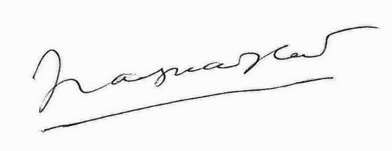
Rev. Canh Tran

